

***Bangladesh University of Business & Technology***

Project Report on

**SOFTWARE DEVELOPMENT IV**

**Course Code:** CSE 400



**Topic: *An Online Shopping App***

**Team Members: Supervised By:**

* Khairul Anam Mubin (17182103286) Md Mamunur Rashid
* Md Sayedur Rahman (17182103297) Lecturer of
* Md Ikbal Hosan (17182103317) Bangladesh University of
* Md Sahrial Alam (17182103334) Business and Technology

Date: 12/7/2021

# **ACKNOWLEDGEMENTS**

We take this occasion to thank God, almighty for blessing us with His grace and taking our endeavour to a successful culmination. We extend our sincere and heartfelt thanks to our esteemed project adviser Md. Mamunur Rashid, Lecturer, Department of CSE, BUBT for his invaluable guidance during the course of this project work. We extend our sincere thanks to him for his continuous helping throughout the project and without his guidance, this project would have been an uphill task. Last but not the least, we would like to thank friends for the support and encouragement they have given us during the course of our work.

Khairul Anam Mubin Md Sayedur Rahman Md Ikbal Hosan Md Sahrial Alam

# **ABSTRACT**

The purpose of this study was to develop a **Shopping Application** to assist in the management of financial with the process of doing this job earlier than going to shopping mall and buying product. So, the development of online base Shopping application introduces the automation in the working of buying and selling and cover the basic functionality of shopping. This project is carried out as a partial fulfillment of the course Software Development Project IV. Creating a shopping application undertaken as a project is based on relevant technologies. The main aim of this project is to develop software shopping. This project has been developed to carry out the processes easily and quickly, which is not possible with the manuals systems. The technology platform in implementing this system uses Android Studio, programming environment with JAVA and Firebase database.

**DEDICATION**

We would like to dedicate this application to

our parents & teachers.

Table of Contents

**ACKNOWLEDGEMENTS** 2

**ABSTRACT** 3

**INTRODUCTION** 7

**1.1 Introduction** 7

**1.2 Problem Statement** 7

**1.3 Motivation** 7

**1.4 Objectives** 8

**1.5 Contributions** 8

**1.6 Conclusion** 8

**EXISTING SYSTEM** 9

**2.1 Introduction** 9

**2.2 Existing System** 9

**2.3 Problems of Existing System** 9

**2.4 Conclusion** 9

**PROPOSED MODEL** 10

**3.1 Introduction** 10

**3.2 ER Diagram** 10

**3.3 Data Flow Diagram** 11

**3.4 Advantages** 11

**EXPERIMENTAL RESULTS** 12

**4.1 Introduction** 12

**4.2 Result Analysis** 12

**4.3 Applications** 12

**4.4 Conclusion** 12

**USER MANUAL** 13

**5.1 Introduction** 13

**5.2.1 H/W Requirements:** 13

**5.2.2 S/W Requirements:** 13

**5.3 Snapshots of the app:** 14

**CONCLUSION** 28

**6.1 Conclusion** 30

**6.2 Future Developments** 30

**CHAPTER- 1**

# **INTRODUCTION**

## **1.1 Introduction**

Online shopping is a form of [electronic commerce](https://en.wikipedia.org/wiki/Electronic_commerce) which allows consumers to directly buy [goods](https://en.wikipedia.org/wiki/Good_(economics)) or [services](https://en.wikipedia.org/wiki/Service_(economics)) from a seller over the [Internet](https://en.wikipedia.org/wiki/Internet) using a [web browser](https://en.wikipedia.org/wiki/Web_browser) or application. This project is an android based shopping system for an existing shopping mall. The project objective is to deliver the online shopping application into android platform. Online shopping is the process whereby consumers directly buy goods or services from a seller in real-time, without an intermediary service, over the Internet. It is a form of electronic commerce. This project is an attempt to provide the advantages of online shopping to customers of a real shop. It helps buying the products in the shop anywhere through internet by using an android device. Thus, the customer will get the service of online shopping and home delivery from his/her favorite shop.

## **1.2 Problem Statement**

As online shopping became a trend nowadays the regular shops are losing their customers to online shops. Customers have effortless shopping experience and saving time through shopping online. For competing with those online brands, if shops are providing an online portal where their customers can shop through internet and get the products at their doors it will increase the number of customers. It’s very necessary to provide an auto calculation process according to needs.

## **1.3 Motivation**

Online shopping application has transformed into one of the most popular app, both for consumers and owner. It provides a broad range of benefits such as 24/7 opportunity to purchase, online catalogues, comparative pricing, cost efficiency, less time consuming and a lot more. These are the reasons why we believe that this app is likely to grow in greater popularity in the future. In this aspect we focus on recognizing the motivational factors of online shopping. We believe that in the development of the future characteristics of e-commerce, future patterns of buying behavior would play a significant role.

## **1.4 Objectives**

* To provide an android application for online shopping of products in an existing shop.
* To provide user friendly system
* To provide error free system
* To handle all the products as an admin/owner
* Different interface for admin and consumers
* Adding product or changing information facility about products for at any time for admin
* Changing information process for consumers.

## **1.5 Contributions**

As this app is for an existing shopping mall, this app will be useful for the shop owner of the mall and probable customer of those shop in together.

## **1.6 Conclusion**

In this technology-based era, we need to move forward with technology in every aspect of our life. As shopping is a key part of our life, an android shopping application can be profitable and beneficial for both customers and consumers.

**CHAPTER- 2**

# **EXISTING SYSTEM**

## **2.1 Introduction**

Now-a-days peoples like online shopping more than ever. In according to keep pace with other businessmen one should start online shopping system for their shop. As android users are increasing day by day, an android application will be very thoughtful in this case. In this chapter we discussed about existing system and its problems.

## **2.2 Existing System**

Our current system for shop is manual. Customers have to come in physical shop, choose product by visiting whole store and buy it. If sometimes required product is not available in the shop, customers time gone waste. Customers who live far away from physical shop cannot frequently visit the shop anytime.

## **2.3 Problems of Existing System**

* + It is less user-friendly.
  + User must go to shop and select products.
  + It is a time-consuming process.
  + Not in reach of distant users.

## **2.4 Conclusion**

By removing back draws of existing system, an android based online shopping application can be very useful for both customer and manager of shop. Customer can save time and energy and do a relax shopping whereas for shop owner can earn more profit.

**CHAPTER-3**

# **PROPOSED MODEL**

## **3.1 Introduction**

We named our project as “Compras BD”. This project required an app to provide online details to the customer of the specified products. In this project, there is no intermediary service. Both sales and purchase transaction are completed electronically. First user will register his/her account by their respective phone number and password. Later on, they can access the account by phone number and password. User can view the product, add the product to cart, delete from cart. In addition, Manager can new add products, view the order list, and confirm the orders.

## **3.2 ER Diagram**

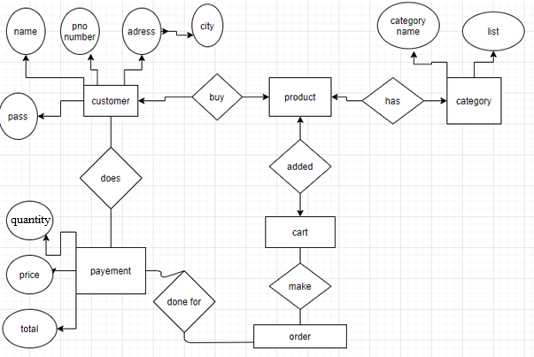

## **3.3 Data Flow Diagram**

View and Buy products

Add/delete/change Products

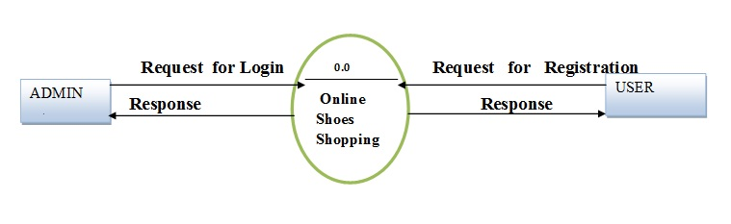

0.0

Online Shopping

## **3.4 Advantages**

In this project, customer can purchase items from the comfort of their own respective place. The Advantages of this project are:

* Shopping is more convenient for the customer using internet
* can save time and effort of the customer
* Customer can buy more than one product of a type or others at a time through internet
* Can get detailed information of the product
* Customer can view products anytime.

**CHAPTER- 4**

# **EXPERIMENTAL RESULTS**

## **4.1 Introduction**

In previous chapter we discussed about proposed model and implementation. In this chapter we are showing results of experiments of using the application.

## **4.2 Result Analysis**

Main purpose of our project was to develop an online shopping android application for an existing shop. We implemented the android application and this application allows admin to manage products such as add new product or edit product or delete product efficiently. User can list favorite product and add product to carts and order successfully.

## **4.3 Applications**

As this android application is for an existing shop, this app can be very useful for both shop manager and customers. Customers who live far away from the physical shop or the customers who wants to save time and energy doing online shopping can use it easily.

## **4.4 Conclusion**

According to our goal building an online shopping android application, we successfully implemented the application. It works as our expectations.

**CHAPTER- 5**

# **USER MANUAL**

## **5.1 Introduction**

Our application is a user-friendly online shopping system. This chapter is a documentation of user manual. We discussed in this chapter about how users or manager will use this android application.

## **5.2.1 H/W Requirements:**

Hard Disk: Minimum 10 GB

Ram: Minimum 4GB

Operating System supported: Windows XP, Windows 7,8,10

## **5.2.2 S/W Requirements:**

Operating System: Windows OS

Framework: Android Studio

Language: Java

Database: Firebase Real-time Database

Tool: Android studio, VScode, Chrome

Note: must be connected with internet/wifi

## **5.3 Snapshots of the app:**

This is the first view of the app.Compras BD is the app name. Here compras is a latin word which means shopping



**Fig :** First view of the app

User can join/register from this page or login if anyone have an account by clicking on the button.

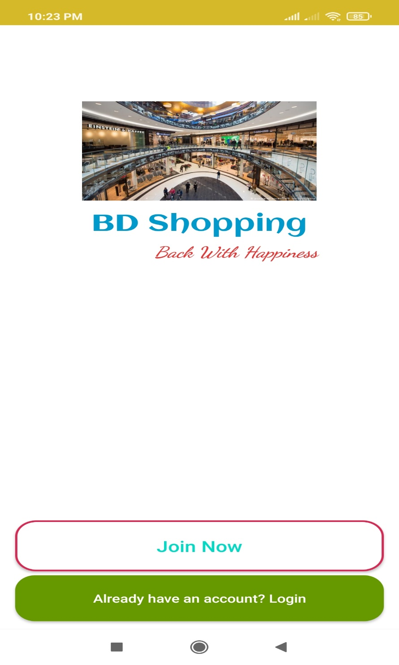

**Fig :** Registration/login page

A person can join the app by giving all the information.

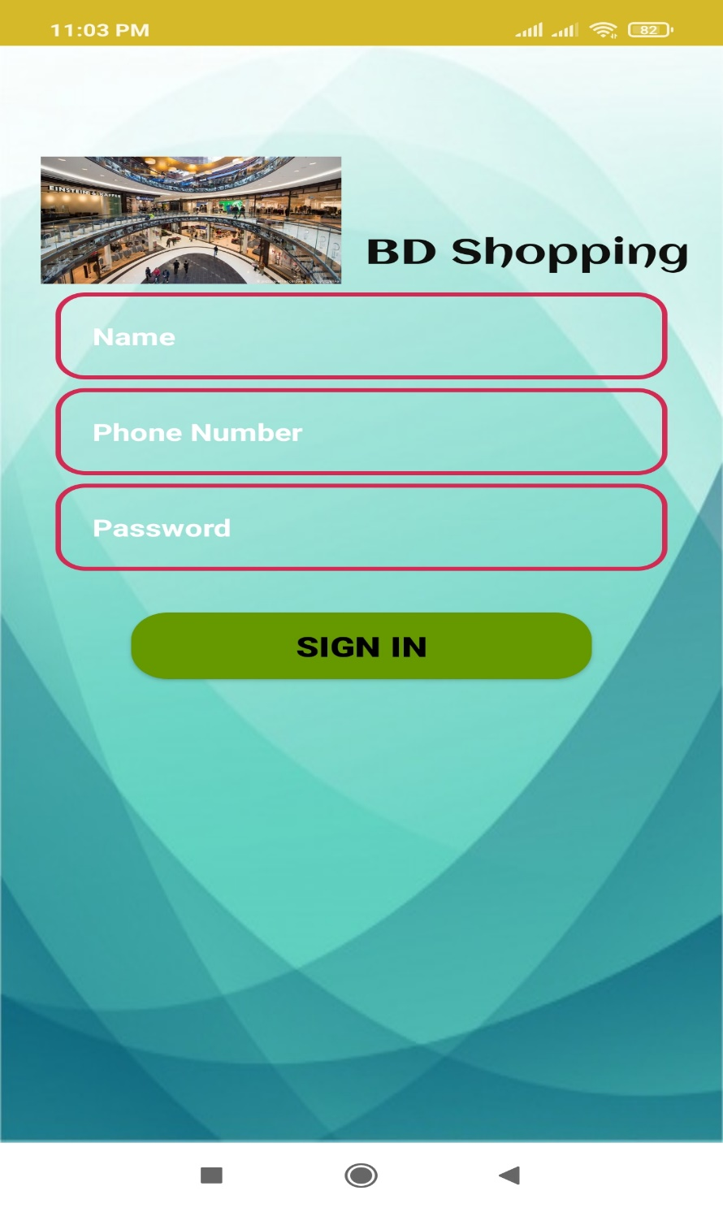

**Fig :** sign in

If already have an account login through phone number and password.

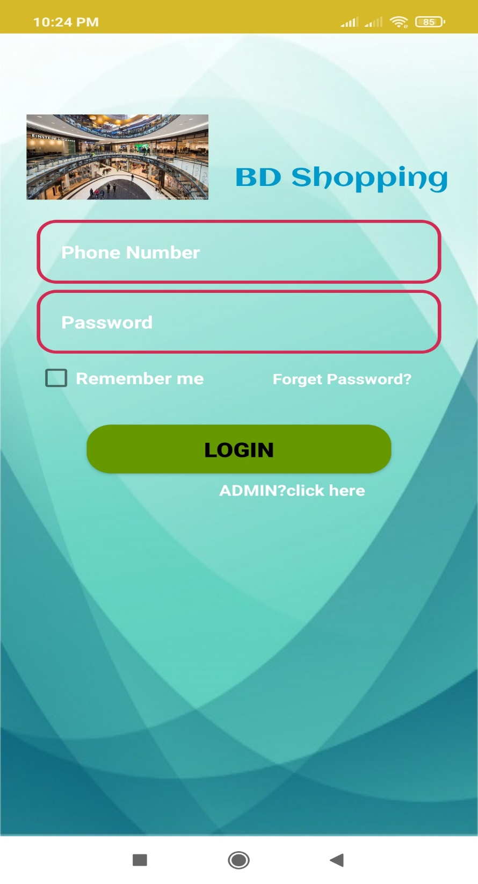

**Fig :** login

An user can reset his password from this page. For securing more there are also some ques. If user forgets his password then he can reset his password by answering this questions.

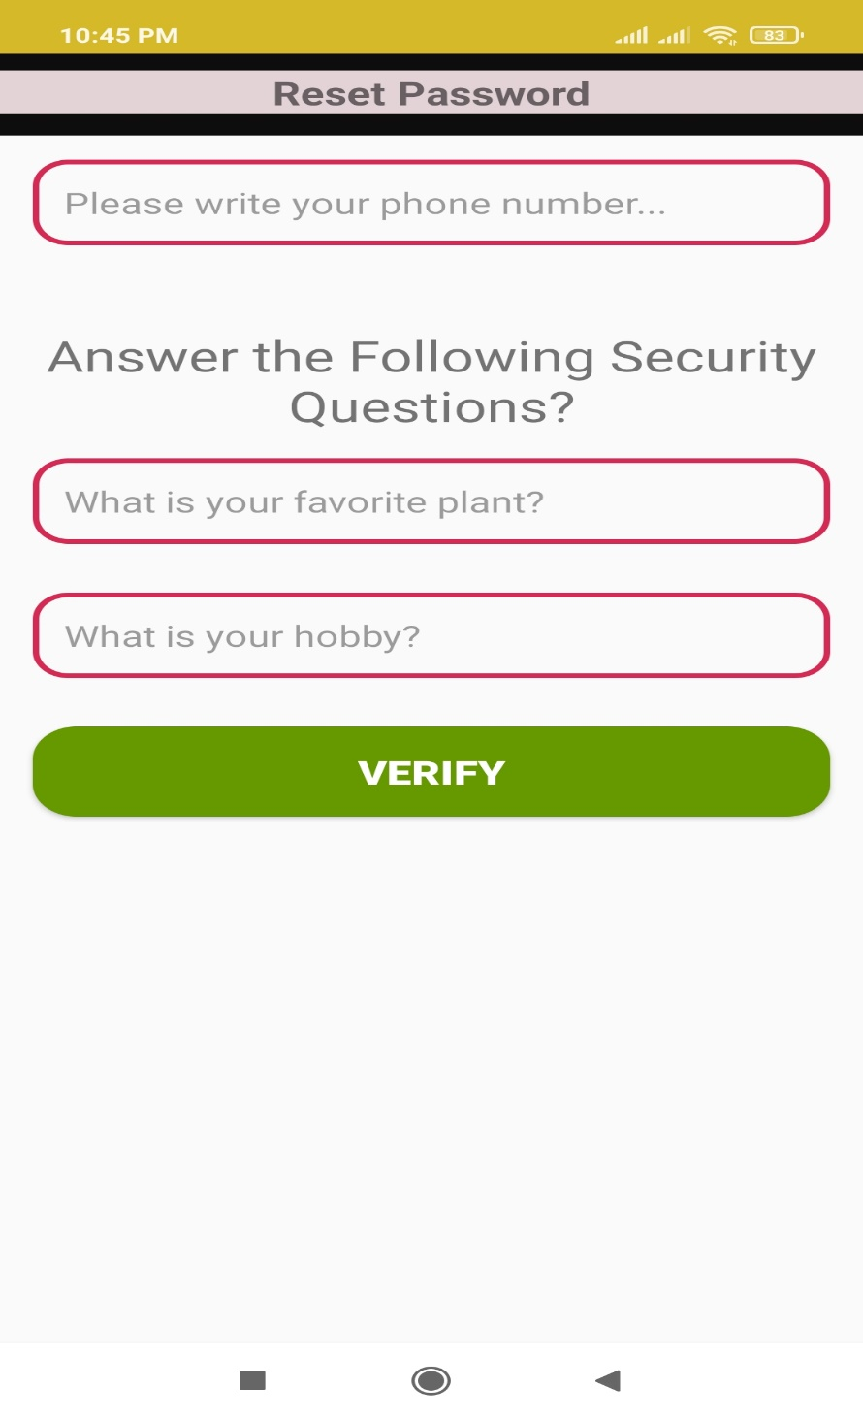

**Fig :** reset password

Here user can update his profile, add or change profile picture.

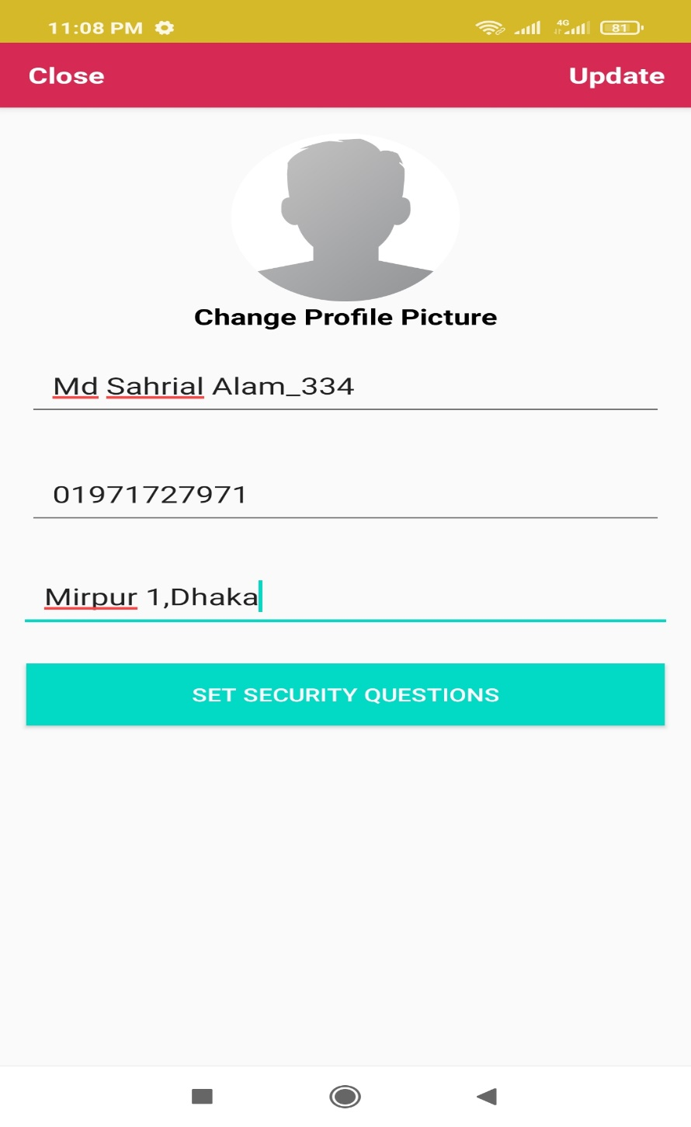

**Fig :** update profile

From this page user can see his cart, wish list for favourite product and also search for products. User can also go to setting for information or log out from here.

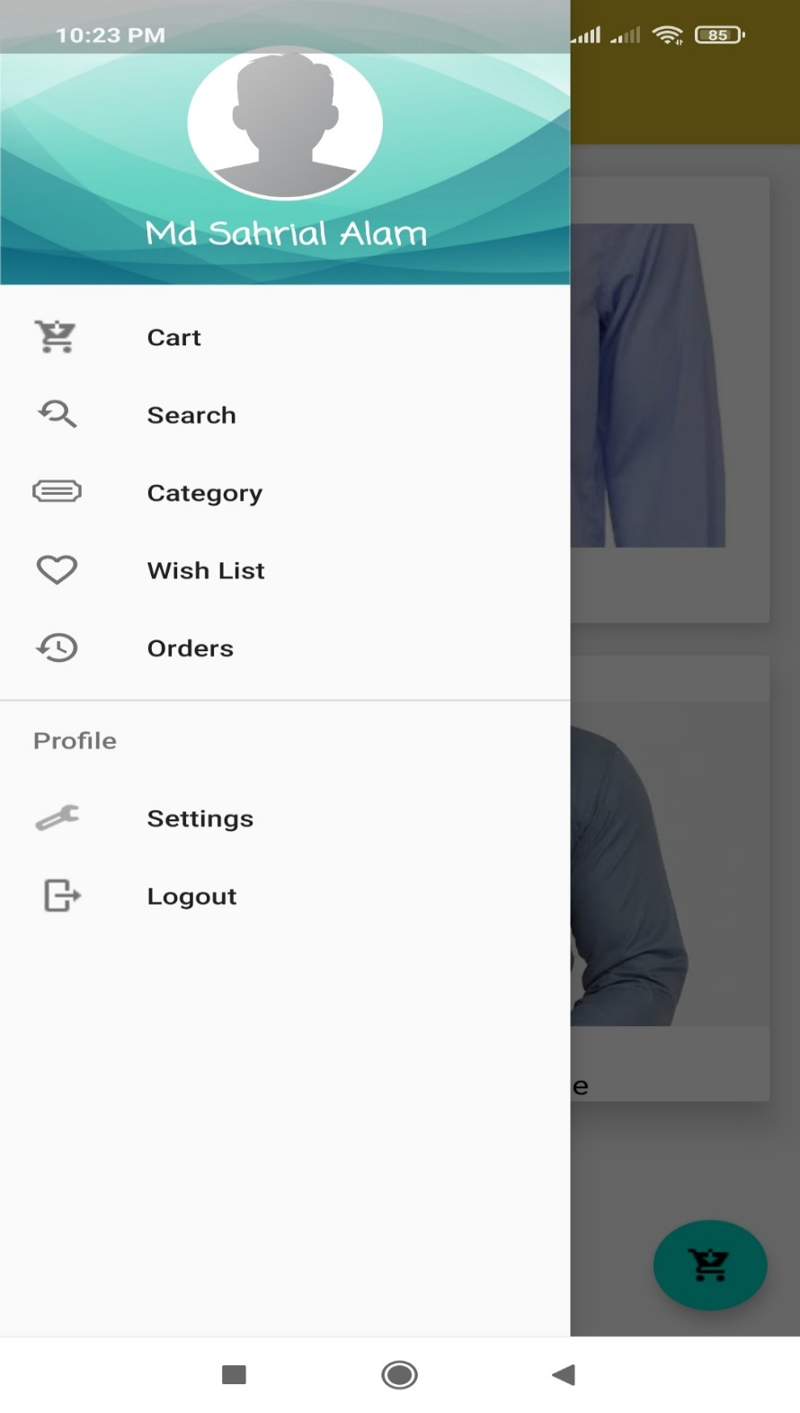

**Fig :** necessary things for user

This is the home page. All the products have been here serially according to adding time.

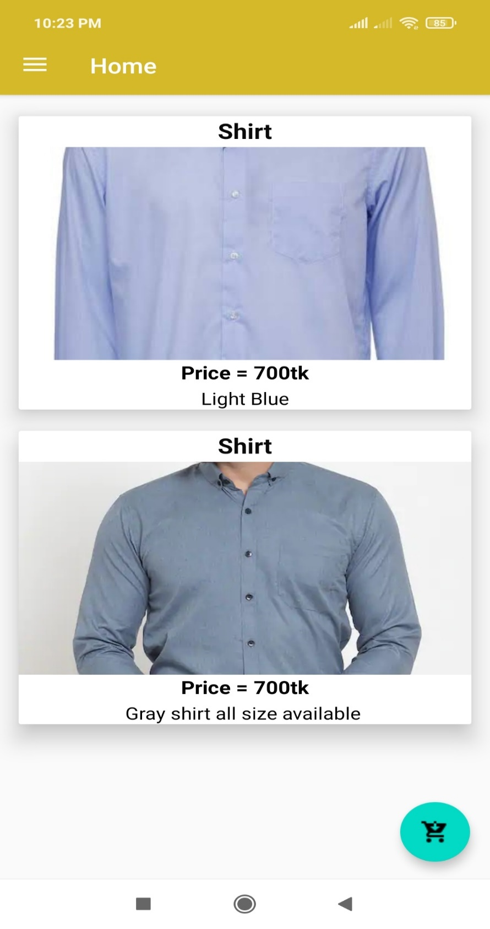

**Fig :** home page

Here the product can be added to cart by using “+” sign . The details of the product are under the picture.

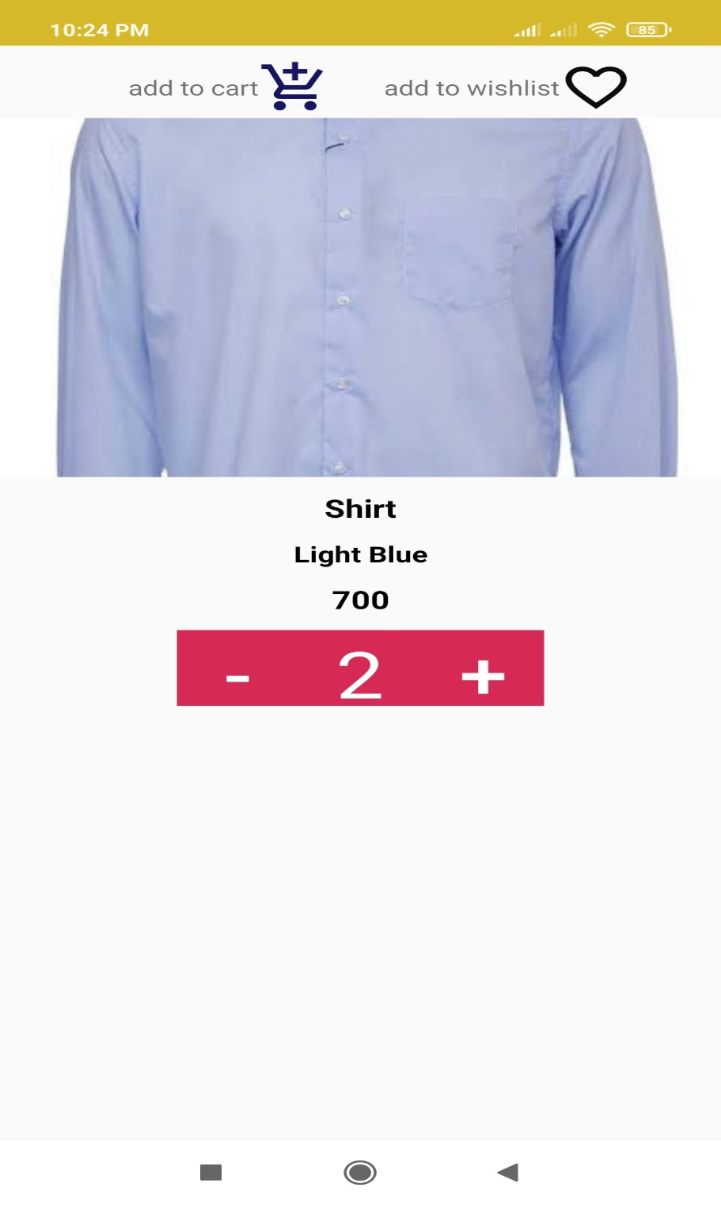

**Fig :** detailed view of product

This is the cart view of the user where user can easily observe all the product and prize money of all the products.

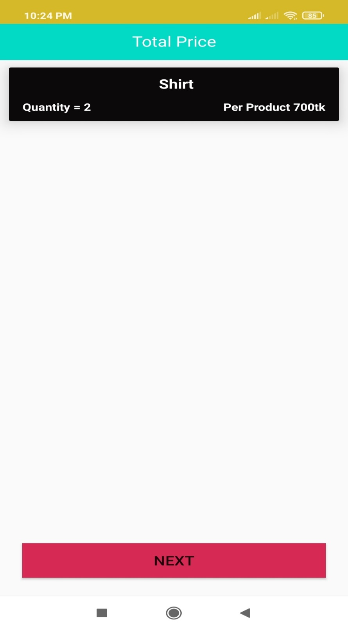

**Fig :** cart view

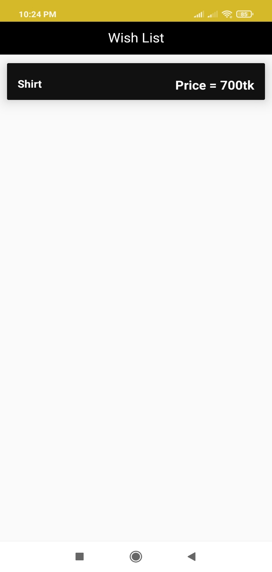

**Fig :** Wish List

For confirming an order user must give the information for delivering product.

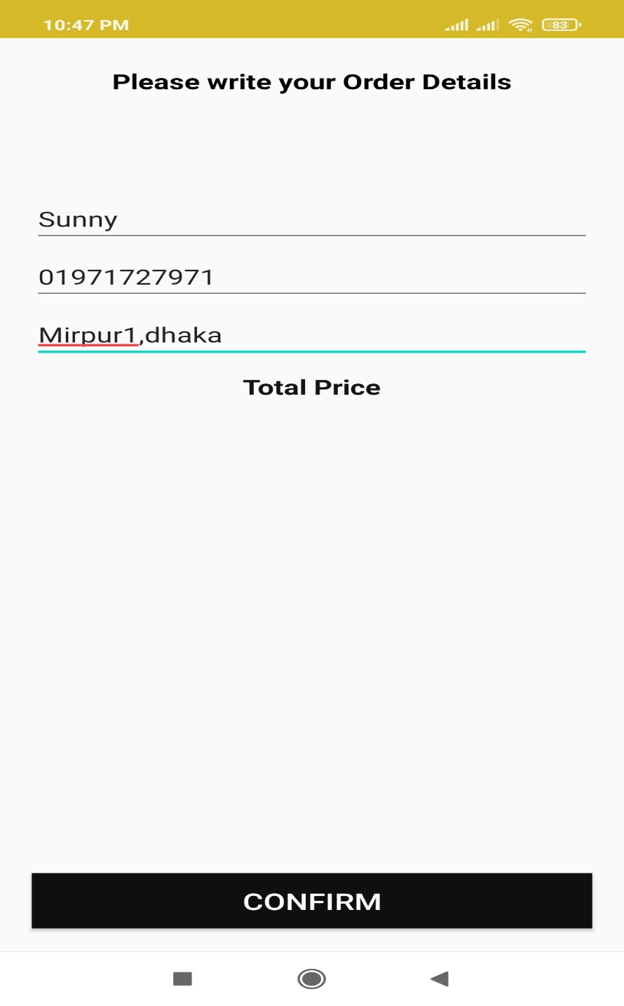

**Fig :** delivery info

**Admin panel :**

Admin can add new product and also maintain the existing products any category.

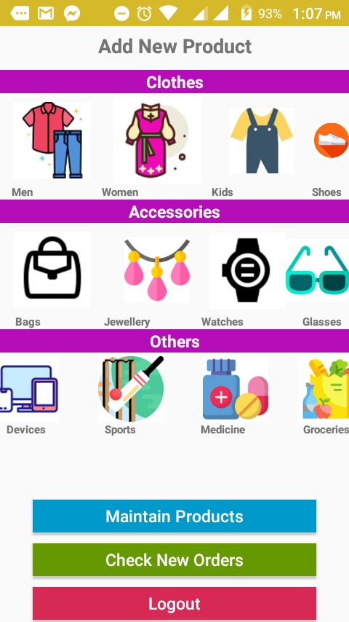

**Fig :** adding product

Admin can check new orders, observe the information of the consumer’s choice and approve the order by login into the app as an admin.

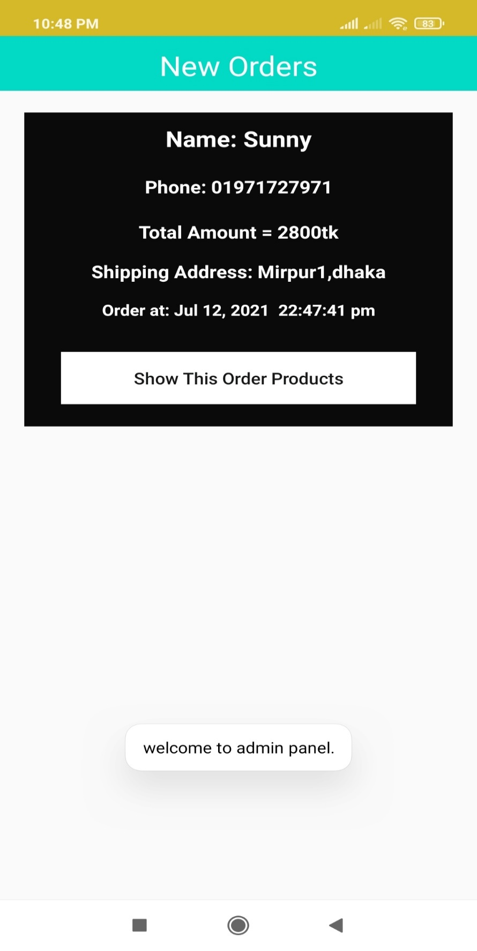

**Fig :** getting Customer’s order

Here is the process of adding new product.Select the product’s image,enter the name,price and all the information of the product.

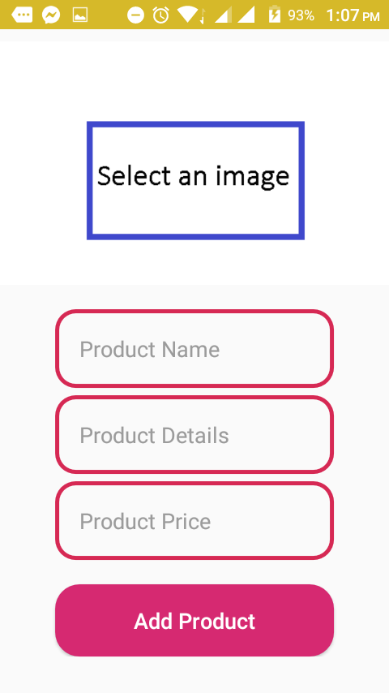

**Fig :** adding product

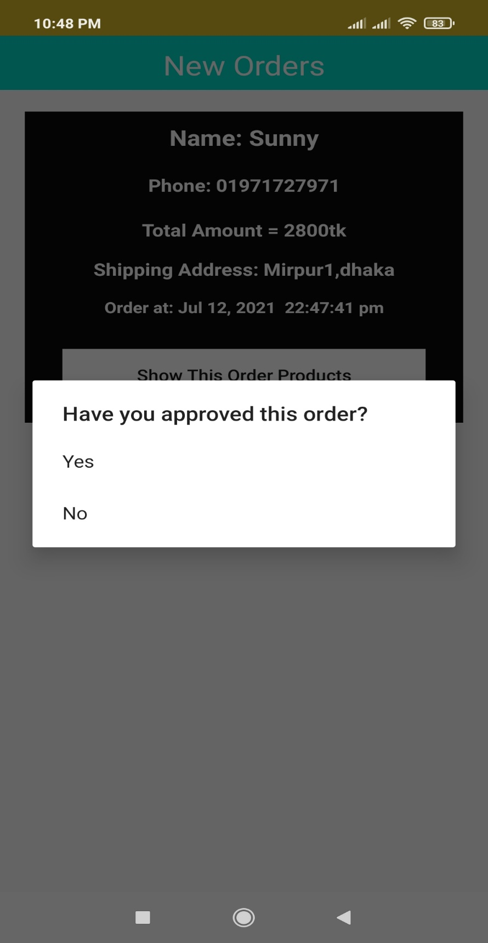

**Fig :** Confirm Order

**CHAPTER-6**

# **CONCLUSION**

## **6.1 Conclusion**

In this world people want to have an easier lifestyle. Having this thought in our mind, we have tried to make this app to make shopping easier through online. The online shopping is now very popular all over the world. The application has been developed with much care and we have tried to make it free of errors. It is very efficient and less time consuming. It is also very easy to operate. The purpose of this project is to develop an android application for purchasing items from the shop. This project has helped us in gaining valuable information and practical knowledge. This project has given us great satisfaction in having designed an application**.**

## **6.2 Future Developments**

There is scope for further development in our project. These are:

* The security system will be upgraded.
* Online payment system will be added.
* Customer’s information details auto refilled system will be added.
* Search product option will be upgraded.
* Product categories will be upgraded.